**Role of oral anticoagulants in the context of the COVID-19 pandemic**

## **Study Protocol**

**Version:** v1.0

**Date: 2 Sep 2020**

This is a collaboration between the following institutions as part of OpenSAFELY.org:

* The DataLab, Nuffield Department of Primary Care Health Sciences, University of Oxford, OX26GG
* Electronic Health Records Research Group, Department of Non-communicable Disease Epidemiology, London School of Hygiene and Tropical Medicine

## 

## 

## 

## 

## 

## 

## 

## 

## 

## **Table Content**

**Study Protocol** **1**

**Table Content** **2**

**Introduction** **3**

**Objectives** **3**

**Methods** **4**

Data Source 4

Study Design and Population 5

Use of OACs versus non-use of OACs 5

Vitamin K antagonist versus DOACs 5

Study Measures 6

Exposures 6

Use of OACs versus non-use of OACs 6

Vitamin K antagonist versus DOACs 6

Follow up and Outcomes 7

Use of OACs versus non-use of OACs 7

Vitamin K antagonist versus DOACs 8

Covariates 9

Missing Data 11

Statistical Analysis 11

Use of OACs versus non-use of OACs 11

Vitamin K antagonist versus DOACs 11

Exploratory Objectives 14

**Strengths and Limitations** **15**

**References** **17**

## 

## **Introduction**

Coronavirus disease 2019 (COVID-19) has been diagnosed in approximately 25 million patients with >848,000 deaths in >200 countries as of 2nd September 2020.[1](https://paperpile.com/c/6ds14r/laPF) A complex picture is emerging about COVID-19 and coagulation, whereby serious illness with COVID-19 appears to be accompanied by increased thrombotic events and bleeding.[2–6](https://paperpile.com/c/6ds14r/EbAa+3S3Z+Ra31+Mw6y+zgbx)

Recent studies reported that anticoagulant use, particularly low molecular weight heparin (LMWH), lowers the risk of pulmonary embolism and mortality during hospitalisation among patients with COVID-19.[7–9](https://paperpile.com/c/6ds14r/oLJs+eDeJ+w7Zz) While anticoagulants appear to be a useful treatment option for hospitalised patients with COVID-19, limited studies have investigated any potential protective role of regular, routine use of oral anticoagulants (OACs) during the pandemic in terms of COVID-19 related outcomes. Importantly, use of OAC treatment is partly threshold based; according to the guidelines for the management of patients with atrial fibrillation,[10,11](https://paperpile.com/c/6ds14r/XI7J+kkk8) people with a CHA₂DS₂-VASc score (used to predict risk of stroke) of ≥2 should be offered an anticoagulant. A better understanding of the impact of OACs on COVID outcomes may alter the balance of benefits and risks for those just below such a threshold. Two studies reported no association between pre-admission anticoagulants and in-patient mortality among hospitalised patients with COVID-19 but they are of small sample size and not general population based.[12,13](https://paperpile.com/c/6ds14r/EEVi+4kuN)

In addition, reduced vitamin K status, has recently been reported as a consequence of COVID-19 infection, with a correlation between vitamin K status and severity of COVID-19.[14](https://paperpile.com/c/6ds14r/Ce4m) This might have an implication for warfarin users (a vitamin K antagonist and anticoagulant); warfarin depletes functional vitamin K reserves for the synthesis of active clotting factors, and might therefore be associated with more severe COVID-19 disease. Unlike warfarin, direct oral anticoagulants (DOACs) which is an alternative class of anticoagulants, do not act on vitamin K pathways to prevent blood clots. They might be a better treatment option for treating coagulation related disorders whilst also preventing serious COVID-19 related outcomes. To date, the clinical evidence of the effects of warfarin compared with DOACs on COVID-19 related outcomes is lacking.

We therefore set out to investigate 1) the association between routine use of OACs and COVID-19 related outcomes between OAC treated, untreated people with atrial fibrillation and general population; 2) the association between warfarin and COVID-19 related outcomes, compared with DOACs among patients with atrial fibrillation.

## **Objectives**

The specific objectives of the study are:

1. Investigate the association between OAC use (including warfarin and DOACs) and hospital admission due to COVID-19 and COVID-19 related deaths, compared with non-OAC use.
2. Investigate the association between warfarin and hospital admission due to COVID-19 and COVID-19 related deaths, compared with DOACs.

***Exploratory Objectives***

1. Investigate the association between OAC use and ever being tested for SARS-CoV-2, and first ever positive result for SARS-CoV-2, compared with non-OAC use.
2. Investigate the association between warfarin and ever being tested for SARS-CoV-2, and first ever positive result for SARS-CoV-2, compared with DOACs.
3. If either a positive or negative effect of OAC use on outcomes of interest is found, use quantitative bias analysis to quantify the strength of unmeasured confounding that would need to be present for the association to have been solely explained by unmeasured confounding.

## **Methods**

### ***Data Source***

We will use data from general practice (GP) records, obtained from the GP software provider The Phoenix Partnership (TPP), linked to COVID-19 inpatient hospital death notifications and Secondary Uses Service (SUS). We will also use SARS-CoV-2 antigen testing data from the Second Generation Surveillance System (SGSS) for the exploratory objective. The data will be accessed, linked and analysed through OpenSAFELY.org - a new data analytics platform created to address urgent questions relating to the epidemiology and treatment of COVID-19 in England, hosted by TPP. OpenSAFELY provides a secure software interface that allows NHS records to be pseudonymised, linked and analysed in near real-time; the GP patient data held on OpenSAFELY never leaves TPP’s secure environment; other datasets are linked to it.

The research dataset analysed through OpenSAFELY is based on GP records retrieved from the TPP SystmOne electronic health record system. These data include diagnoses, medicines, physiological parameters, such as body mass index and vital signs, prior investigations, such as blood test results, and basic socio-demographics for almost 24 million individuals – approximately 40% of the English population. Data extracted by TPP SystmOne have previously been used in medical research, as part of the ResearchOne dataset. These records were subsequently linked to data from a number of other organisations who were directed under the Health Service (Control of Patient Information) Regulations 2002 to make their data available for COVID-19 research with the OpenSAFELY initiative. Currently, linkage is possible to: (1) the NHSE/NHSX Emergency Care Data Set (ECDS), which contains data on emergency attendance at A&E clinics across England; (2) the NHSE/NHSX SGSS data on SARS-CoV-2 test results; (3) the Intensive Care National Audit & Research Centre (ICNARC) Case Mix Programme, containing data on COVID-19 related Intensive Treatment Units (ITU) admissions; (4) the NHSE/NHSX COVID-19 Patient Notification System (CPNS) data on deaths among COVID-19 inpatients occurring in hospitals; (5) in-patient data from SUS; and (6) Office for National Statistics (ONS) death data, which includes information on all deaths, including those due to non-COVID-19 causes as well as those occurring outside the hospital setting.

All data is held in a secure research environment hosted by TPP, which is a Tier 3 data centre, accredited to NHS Digital standards for centrally hosted clinical systems (ISO 27001 standardand IG Toolkit version 2).

### ***Study Design and Population***

We will use a population-based cohort design.

#### *Use of OACs versus non-use of OACs*

*Inclusion criteria*

First, we will identify people who had a diagnosis of atrial fibrillation on or before 1st March 2020. In order to reduce confounding by indication, we will limit the cohort to those who had a CHA₂DS₂-VASc score of 2.

*Exclusion criteria:*

* Less than 12 months of primary care records whilst registered in a TPP practice available before the first recorded OAC prescription, which may preclude adequate characterisation of potentially important confounding variables.
* <18 years of age or >110 years of age at 1st March 2020
* Missing sex
* Missing Index of Multiple Deprivation

Although we attempt to reduce confounding by restricting the cohort to people with atrial fibrillation, people who were not prescribed an OAC might have some clinical reasons other than a CHA₂DS₂-VASc score. If so, these people might have more comorbidities than those prescribed an OAC which might bias the result away from null. To explore this, we will include a second comparison group, identified from the general population. As this group of people is less likely to be frailer than the AF treated population, using this comparison group will help us explore the impact of confounding. Each patient with atrial fibrillation who was prescribed an OAC will be matched to 10 people without atrial fibrillation (patient registered in TPP) based on age and sex on 1st March 2020. The same exclusion criteria applied to the AF population will also be applied. In addition, people who had no GP visit within one year before 1st March 2020 will be excluded. Moreover, they will not have an OAC prescription within 4 months before 1st March 2020 to be included in this comparison group.

#### *Vitamin K antagonist versus DOACs*

*Inclusion criteria*

We will identify people who had a diagnosis of atrial fibrillation on or before 1st March 2020.

*Exclusion criteria:*

* Less than 12 months of primary care records whilst registered in a TPP practice available before the first recorded OAC prescription, which may preclude adequate characterisation of potentially important confounding variables.
* People with mitral stenosis or prosthetic mechanical valves because DOACs are not indicated in this population.
* People who had end-stage chronic kidney disease (eGFR < 15mL/min) or are on dialysis as DOACs are not indicated in this population.
* People who had antiphospholipid antibody syndrome
* <18 years of age or >110 years of age at 1st March 2020
* Missing gender
* Missing Index of Multiple Deprivation

### **Study Measures**

Discussions and decisions on every measure have been documented before implementing the final underlying code to complete the analysis. Detailed information on compilation and sources for every individual codelist is available at <https://codelists.opensafely.org/> and the lists are available for inspection and re-use by the broader research community.

### **Exposures**

#### *Use of OACs versus non-use of OACs*

The exposure of interest is OACs prescribed in the 4 months prior to 1st Mar 2020. This can capture usage in pre-pandemic conditions within a reasonable timeframe (Table 1). This date was chosen due to reports of substantial early and over-ordering of medicines and appeals by the NHS not to extend prescription durations in March. Therefore, prescribing patterns from March may not represent usual usage e.g. with respect to levels of adherence. The unexposed group will be people who do not have a record of an OAC prescription in the 4 months prior to 1st Mar 2020.

**Table 1. Operational Definition for exposure of interest**

|  |  |  |  |  |
| --- | --- | --- | --- | --- |
| **Variable** | **Variable level** | **Category** | **Definition** | **Timeframe** |
| Drug Exposure | 0 | Unexposed group | No record of OAC prescription | 4 months prior to 1st Mar 2020 |
| 1 | Exposed group | At least one OAC prescription (warfarin/ dabigatran/rivaroxaban/apixaban/edoxaban) |

#### *Vitamin K antagonist versus DOACs*

The exposure of interest is DOAC (as the latest OAC prescription) prescribed in the 4 months prior to 1st Mar 2020 (Table 2). The comparison group will be people who were prescribed warfarin (as the latest OAC prescription) in the 4 months prior to 1st Mar 2020. If both warfarin and DOACs were prescribed on the same day as the latest prescription, we will classify them as warfarin users. All patients with AF will be included, regardless of CHA₂DS₂-VASc score.

**Table 2. Operational Definition for exposure of interest**

|  |  |  |  |  |
| --- | --- | --- | --- | --- |
| **Variable** | **Variable level** | **Category** | **Definition** | **Timeframe** |
| Drug Exposure | 0 | Warfarin | Latest record of warfarin prescription | 4 months prior to 1st Mar 2020 |
| 1 | DOACs | Latest record of DOAC prescription (dabigatran/rivaroxaban/apixaban/edoxaban) |

#### 

### **Follow up and Outcomes**

#### *Use of OACs versus non-use of OACs*

Follow up will begin on 1st March 2020, considered the start of risk for experiencing the outcomes due to the dynamics of the coronavirus outbreak in the UK and end at the latest of the outcome of interest in each analysis, deregistration from the TPP practice, death or last date of data availability (Figure 1).

Outcomes will include hospital admission due to COVID-19 (principal diagnosis only to avoid capturing COVID-19 acquired during hospitalisation), and COVID-19 related deaths.

**Figure 1. Illustration of the follow up for the association between oral anticoagulants and COVID-19 related outcomes**

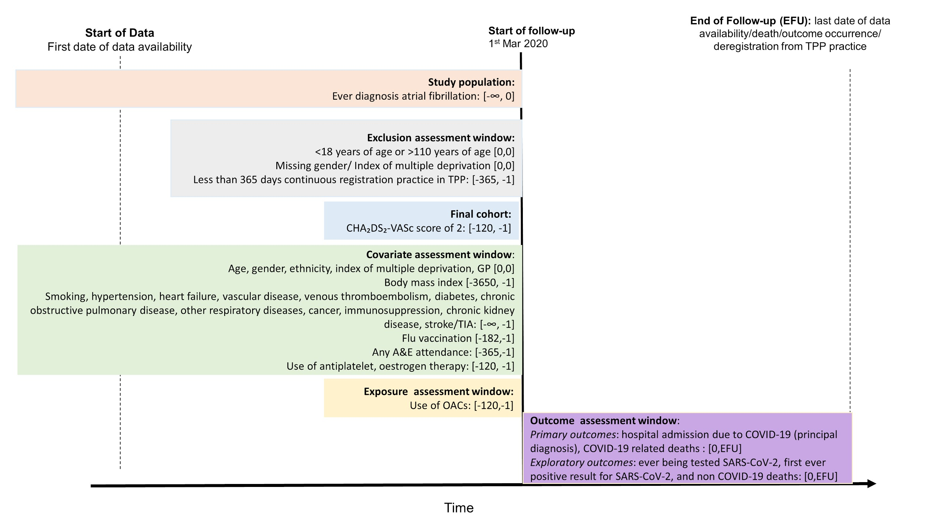

#### *Vitamin K antagonist versus DOACs*

Follow up will begin on 1st March 2020 and end at the latest of the outcome of interest in each analysis, deregistration from the TPP practice, drug switching, death or last date of data availability (Figure 2).

Similarly, outcomes will include hospital admission due to COVID-19 (principal diagnosis) and COVID-19 related deaths.

**Figure 2. Illustration of the follow up for the association between warfarin and COVID-19 related outcomes versus DOACs**

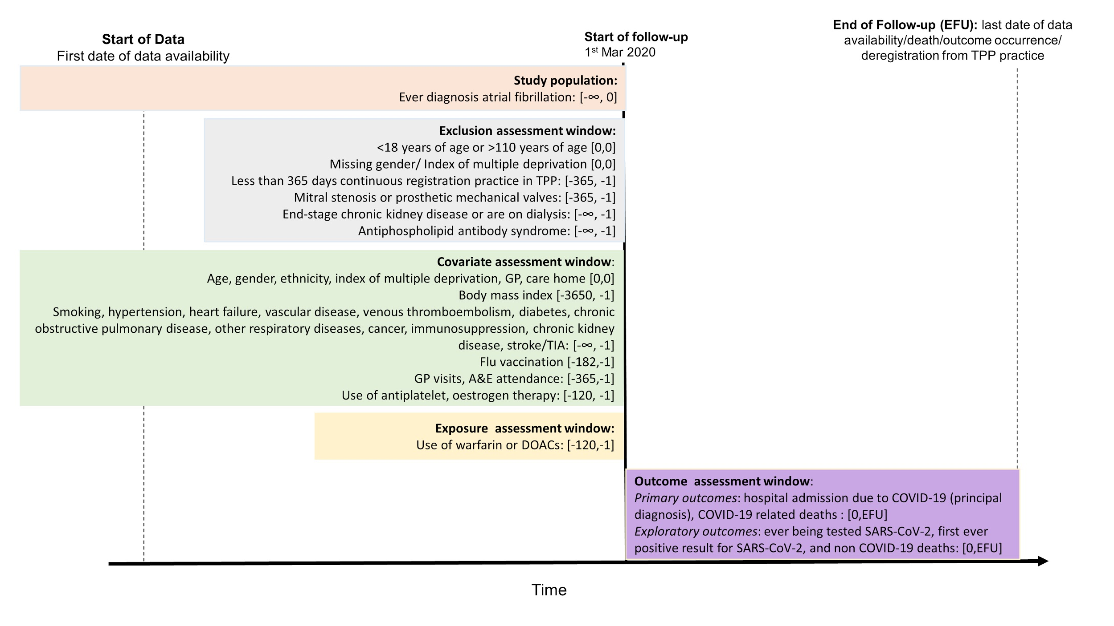

### **Covariates**

The covariates of interest were chosen following discussion with practising clinicians to identify potential important determinants of OAC prescribing and the outcomes of interest. The covariates which were pre-specified as potentially important confounding variables are listed below. Directed Acyclic Graph (DAG) approach is used to identify covariates for objective 1 (Figure 3) and objective 2 (Figure 4). In addition, we will also include risk factors of severe COVID-19 outcomes as other covariates in the fully adjusted model. Definitions and code lists are available at <https://codelists.opensafely.org/> and are available for inspection and re-use by the broader research community. Unless otherwise specified, variables were created using diagnostic codes present ever in a patients’ medical record prior to the start of follow-up for each objective.

Covariates used in DAG adjusted model:

* Age as of 1st March 2020
* Sex
* Ethnicity
* Obesity (identified by Body Mass Index, ascertained from weight measurements within the last 10 years)
* Smoking, most recent code prior to 1st March 2020
* Hypertension
* Heart failure
* Vascular disease (prior myocardial infarction and peripheral arterial disease)
* Stroke/transient ischemic attack
* Venous thromboembolism
* Diabetes, categorised as controlled (HbA1c <58 mmols/mol), uncontrolled (HbA1c ≥58 mmols/mol) or HbA1c not measured.
* Flu vaccination status, between 6 months prior to cohort entry
* Current antiplatelet use, within 4 months of cohort entry (as antiplatelets reduce thrombotic risk which might be linked to less severe COVID-19 disease)
* Current oestrogen therapy use, within 4 months of cohort entry (as oestrogen increases thrombotic risk which might be linked to severe COVID-19 disease)
* Index of Multiple Deprivation (2019)
* Care home (for Objective 2 only)

Additional covariates used in fully adjusted model:

* Chronic obstructive pulmonary disease
* Other respiratory diseases (not including asthma)
* Cancer
* Immunosuppression, including organ transplant, sickle cell anaemia, splenectomy, HIV, a condition inducing permanent immunodeficiency ever diagnosed, or aplastic anaemia or temporary immunodeficiency recorded within the last year
* Chronic Kidney Disease, using creatinine measurements (within 1 year of cohort entry) prior to cohort entry
* GP attendance rate in the year prior to cohort entry, dichotomised as 0 or ≥1
* A&E attendance rate in the year prior to cohort entry, dichotomised as 0 or ≥1

**Figure 3. Directed Acyclic Graph for Objective 1.**

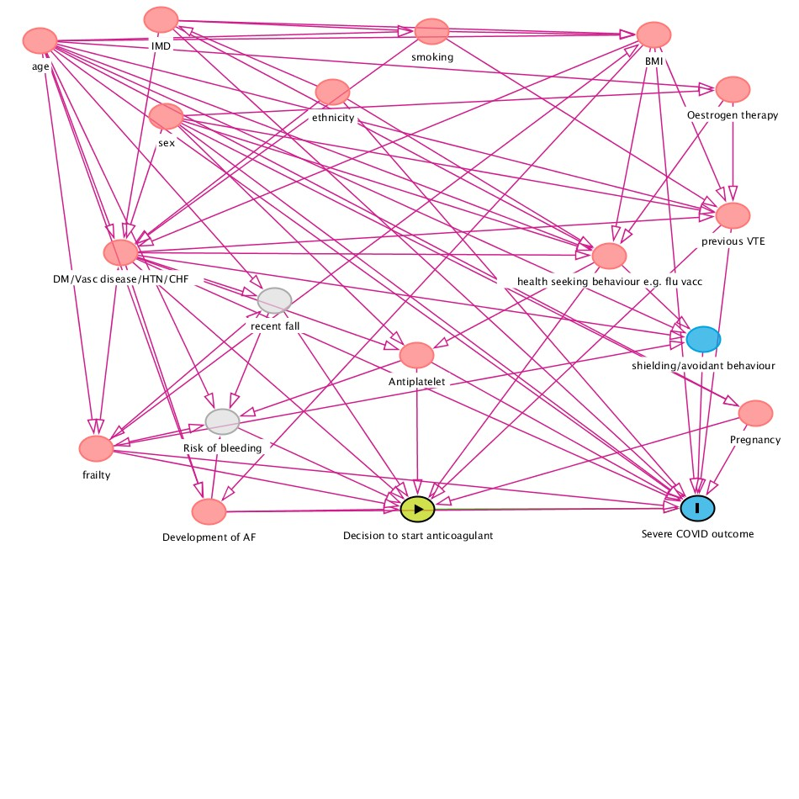

**Figure 4. Directed Acyclic Graph for Objective 2.**

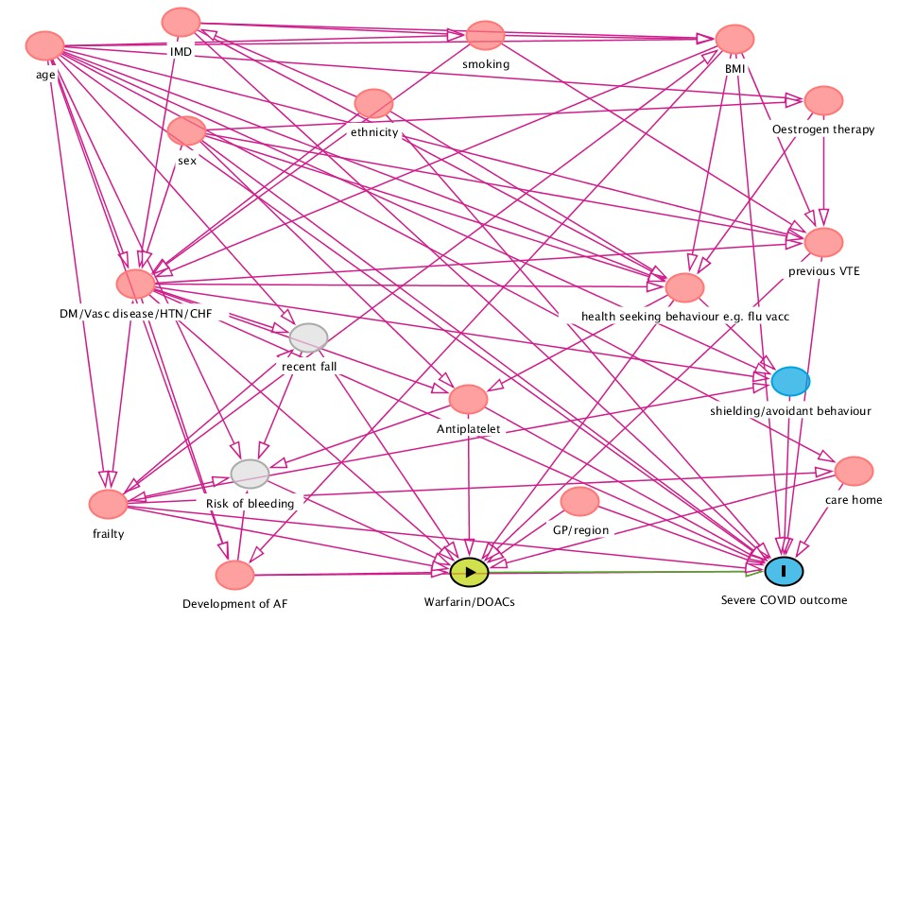

### **Missing Data**

In the primary analysis, those with missing BMI will be assumed non-obese and those with missing smoking information will be assumed to be non-smokers on the assumption that both obesity and smoking would be more likely to be recorded if present. We anticipate ~25% missing data on ethnicity and will exclude this variable from the primary models. A sensitivity analysis will be done amongst people with recorded ethnicity, adjusting for this variable in addition to the others. Patients with missing data on eGFR measurements, who do not have a code for end-stage renal disease, will be assumed to not have chronic kidney disease.

### **Statistical Analysis**

In each analysis, we will present the number of patients meeting each inclusion and exclusion criteria for the cohorts using flowcharts. The characteristics of patients in each group will also be summarised using descriptive statistics.

#### *Use of OACs versus non-use of OACs*

We will compare the risk of outcomes of interest between exposed and unexposed groups using Cox regression with time since cohort entry as the underlying timescale. We will further investigate if the associations vary by types of OACs (i.e. warfarin vs. DOACs).

#### *Vitamin K antagonist versus DOACs*

We will compare the risk of outcomes of interest between warfarin and DOAC groups using Cox regression with time since cohort entry as the underlying timescale. We will further investigate whether the associations vary by types of DOACs if we have adequate power.

For both analyses, we will present adjusted survival curves for each exposure group using the Royston-Parmar model. We will account for competing risk by modelling the cause-specific hazard (i.e. censoring other deaths for COVID-19 death analysis, and censoring any death for other outcomes analysis). Univariable models, models adjusted for age and sex, DAG adjusted model, as well as fully adjusted models will be presented. In fully adjusted models, hazard ratios will be estimated, stratified by general practice. Graphical methods and tests based on Schoenfeld residuals will be used to explore violations of the proportional hazards assumption.

*Post-hoc* models including other adjustments, or removing some adjustment variables may be fit. However, these will be clearly marked as *post-hoc* exploratory work in the presentation of any results.

**Sensitivity Analyses**

1. As antiplatelet use can reduce the risk of blood clots, we will remove people who were prescribed antiplatelet 4 months before cohort entry.
2. We will include non-COVID-19 death as one of the outcomes to explore the impact of confounding. Difference in risk of non-COVID-19 death might imply the health characteristics between exposure groups are different and have not been successfully controlled for. For the analysis comparing between current users and non-users among people with atrial fibrillation, if non-users are generally frailer than OAC users, we could not differentiate whether an expected lower risk of non-COVID-19 death is due to confounding or a real treatment effect, given that we anticipate a beneficial effect of OAC treatment in people with atrial fibrillation compared with no treatment. Therefore, if we observe non-users are generally frailer than OAC users, we will not include non-COVID-19 death as an outcome for this analysis.
3. In the first objective, we will limit the study cohort to people who aged 55 or above to explore the impact of potential confounders in young age, for example, pregnancy.

In the second objective,

1. we will exclude people who were prescribed both warfarin and DOACs on the same day as the latest OAC prescription.
2. we will exclude people who ever had warfarin prescription 4 months before cohort entry in the DOAC group as warfarin is hypothesised to have harmful effect on severe COVID-19 compared with DOAC. Table 3 shows the definition of exposure of interest.
3. we will use time-updated exposure variable (warfarin/DOACs) during the follow-up to evaluate the impact of drug switching and test the robustness of the main analysis.

**Table 3. Definition of exposure of interest.**

|  |  |  |  |  |
| --- | --- | --- | --- | --- |
| **Variable** | **Variable level** | **Category** | **Definition** | **Timeframe** |
| Drug Exposure | 0 | Warfarin | A record of warfarin prescription | 4 months prior to 1st Mar 2020 |
| 1 | DOACs | Meeting both criteria:  1. A record of DOAC prescription (dabigatran/rivaroxaban/apixaban/edoxaban)  2. No record of warfarin |

It should be noted that more sensitivity analyses may be added based on the initial results of analyses. These will be clearly marked as *post-hoc* analyses in any reporting of the results.

### **Exploratory Objectives**

For both analyses, we will explore the first ever positive result for SARS-CoV-2 as an outcome. As our study population is anticipated to be a homogeneous group of people with non-valvular atrial fibrillation (except the non-atrial fibrillation comparison cohort in the first objective), the outcome of the first ever positive result for SARS-CoV-2 is unlikely to be affected by the selective testing. We will also include ever being tested SARS-CoV-2 as one of the outcomes to test our assumption. We will further stratify the associations by time to explore whether the testing for COVID-19 in the UK among this group of people varied over time. However, selective testing might affect the analysis comparing treated people with atrial fibrillation and the non-atrial fibrillation comparison cohort. Therefore, interpretation of this analysis will be made cautiously.

For any non-null association, with 95% confidence intervals wholly above or below 1 in the primary analysis, we will conduct a quantitative bias analysis. This will estimate how strong unmeasured confounding would need to be in order to explain the association. We will use Ding and Vanderweele’s e-value formulae to estimate how strongly associated one or more unmeasured confounders would need to be with exposure and outcome to fully explain the observed association.

## 

## **Strengths and Limitations**

The strengths of this study will include the size of the source population: OpenSAFELY represents one of the largest EHR databases in Europe. This will allow analyses to have high power during this stage of the pandemic. All outcomes are also being recorded and analysed in near real-time, which will allow the number of outcome events to be maximised and ensure analyses are well powered. The richness of the EHR will allow us to characterise patients’ medical history with a relatively high degree of accuracy, as we will not be relying on data being collected during the pandemic to characterise comorbidities. This should allow us to better control for confounding compared to studies conducted solely in the hospital setting. Other strengths will include the pre-specified objectives and analysis plan, which will clearly allow readers to see which hypotheses and analyses were planned in advance. Finally, all source code that is used both to define the study population and run the analysis will be made publicly available for other researchers to both re-use and scrutinize.

However, there are limitations which should be borne in mind when interpreting any results. They would tend to apply to any study addressing this question using non-interventional data, which are not unique to this study. Firstly, although we will attempt to reduce confounding by limiting the study cohort to people with atrial fibrillation for both Objectives and those who had a threshold CHA₂DS₂-VASc score to be prescribed anticoagulants in Objective 1, we cannot entirely remove residual confounding – either due to variables we have not measured, or those we have measured imperfectly. If our analyses are subject to confounding (i.e. people who were not prescribed OACs are generally sicker), we might expect to observe a decreased risk of outcomes among patients recently prescribed OACs compared with those who were not. Comparisons of baseline characteristics will help us explore this. To aid the interpretation of our results, for all detected associations we will quantify the strength an unmeasured confounder would need to remove the observed association using quantitative bias analysis. Any changes over time in the relationship between the exposures of interest and the outcomes will be evaluated as part of checking the assumption of proportional hazards in the Cox regression models. Deviations from proportional hazards will be considered and explored carefully. Regarding covariate selection, pregnancy increases risk of venous thromboembolism and may affect the prescribing decision of oral anticoagulants. However, the data on pregnancy may be unreliably recorded in our database which requires further exploration. Therefore, we will not adjust for pregnancy in this study. Our analyses are also subject to risk of exposure misclassification. First, we do not know whether or not patients were truly taking the medications as prescribed. Second, we are also not able to capture any anticoagulant use during hospitalisation. LMWH or unfractionated heparin might be given during hospitalisation for patients with severe COVID-19 disease to prevent venous thromboembolism. Therefore, we will only capture the effects of routine use of OACs (if any) on severe COVID-19 outcomes before hospitalisation in this study and we might underestimate the effect without accounting for the anticoagulation use during hospitalisation. Figures 5 and 6 further illustrate the stages of COVID-19 disease prognosis and our hypothesis of how routine use of oral anticoagulants might be beneficial/harmful to severe COVID-19 disease.

Given the inherent limitations of the study design, our results should be taken as hypothesis exploring/generating. Multiple studies of different designs, in different populations, will be needed before a conclusive answer relating to the role of oral anticoagulants on COVID-19 related outcomes can be given.

**Figure 5. Potential scenarios of anticoagulant use in different stages of COVID-19 disease.**

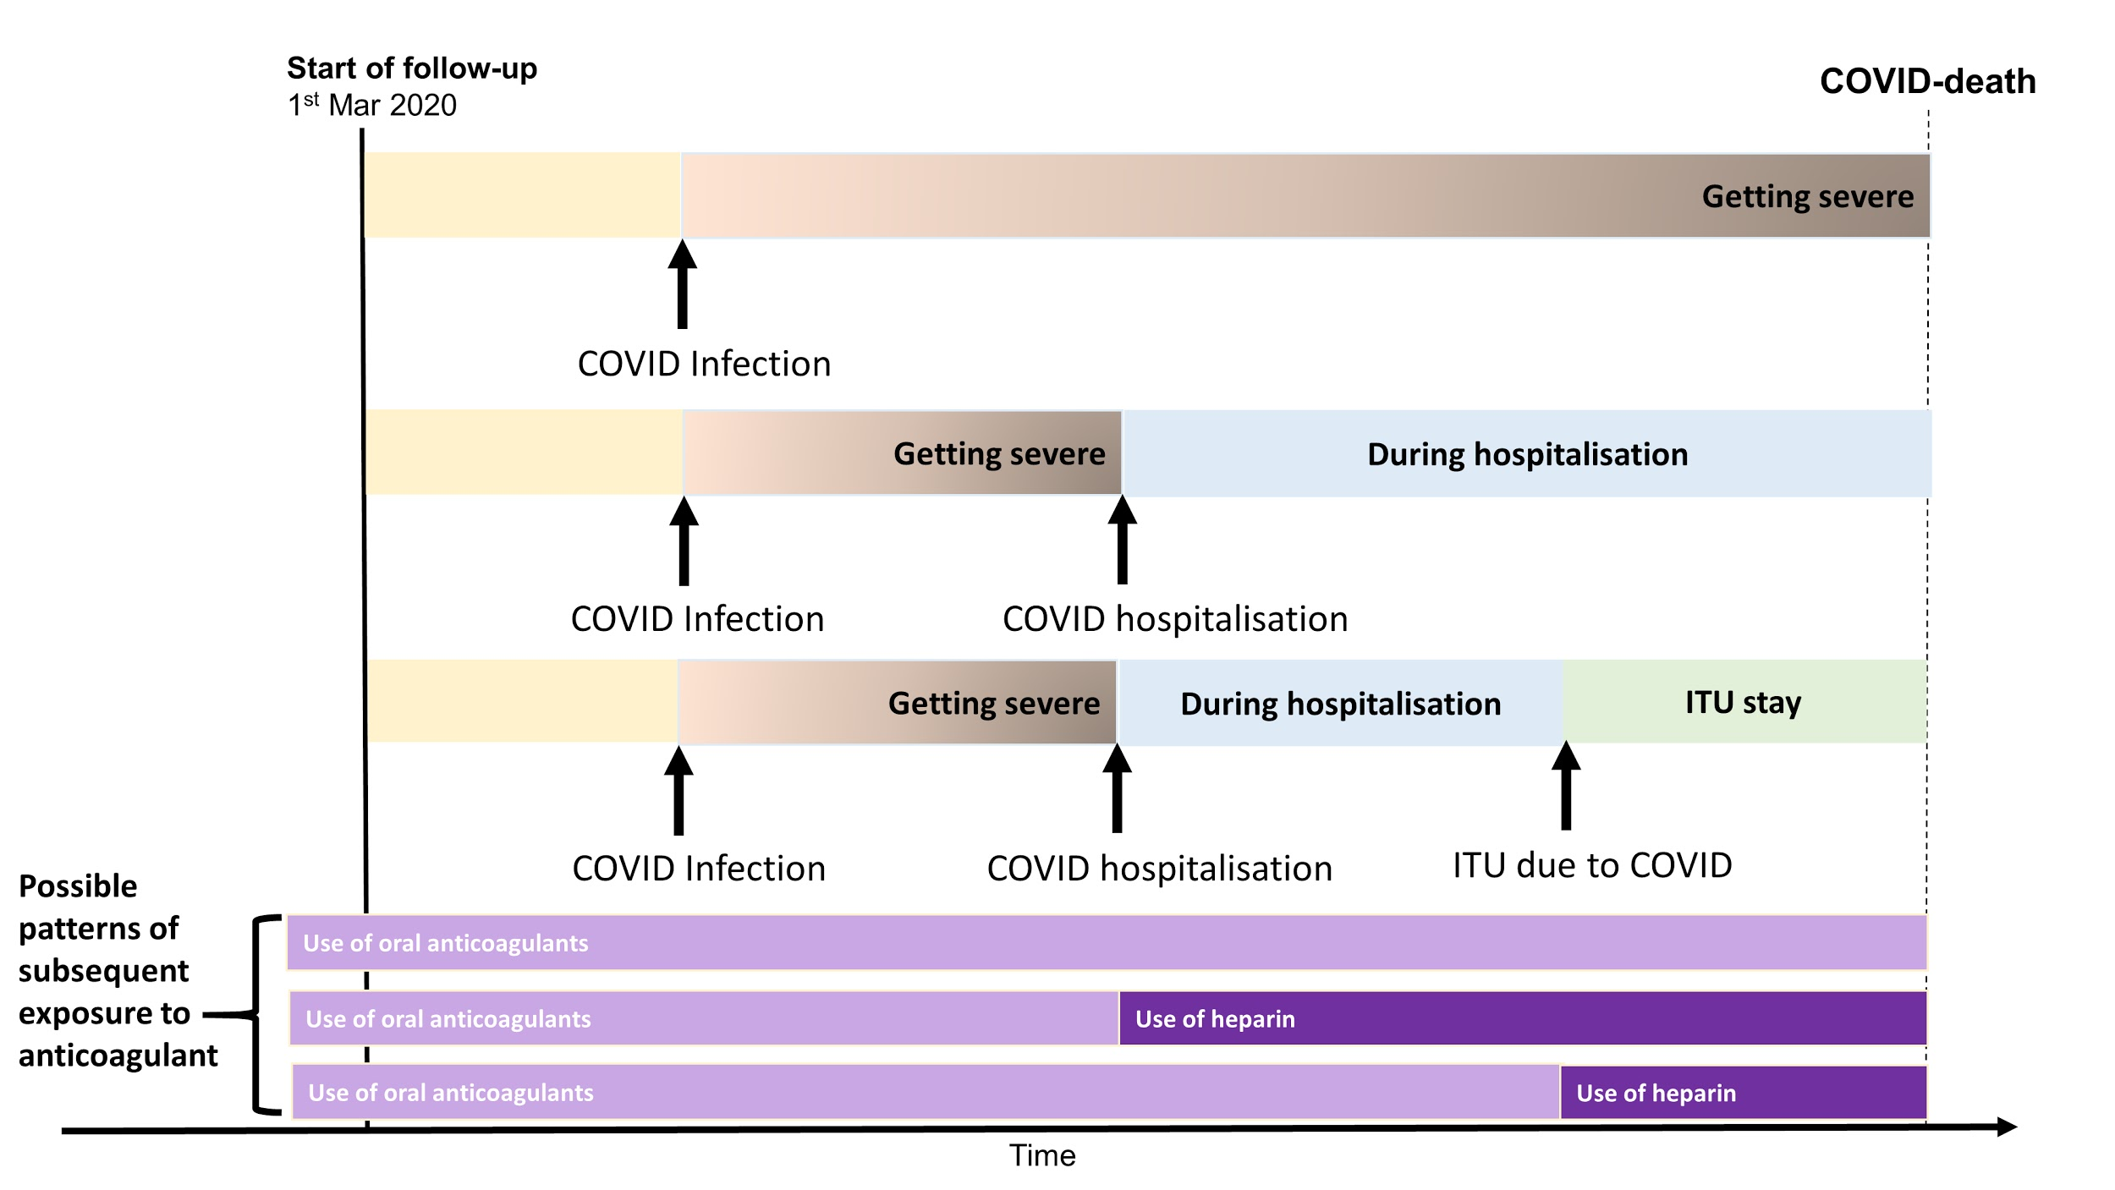

**Figure 6. Potential scenarios of anticoagulant use (including consideration of switching from warfarin to DOAC) in different stages of COVID-19 disease.**

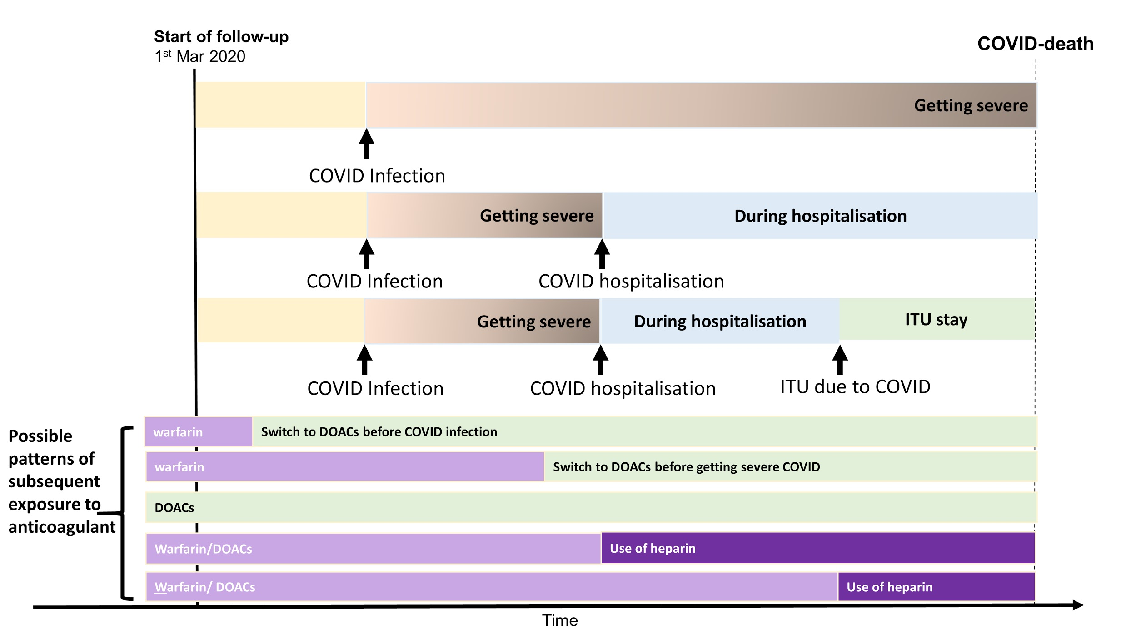

## **References**

1. [World Health Organization. Coronavirus disease (COVID-19). Accessed August 5, 2020.](http://paperpile.com/b/6ds14r/laPF) <https://www.who.int/emergencies/diseases/novel-coronavirus-2019>

2. [Al-Samkari H, Karp Leaf RS, Dzik WH, et al. COVID-19 and coagulation: bleeding and thrombotic manifestations of SARS-CoV-2 infection. *Blood*. 2020;136(4):489-500.](http://paperpile.com/b/6ds14r/EbAa)

3. [Cui S, Chen S, Li X, Liu S, Wang F. Prevalence of venous thromboembolism in patients with severe novel coronavirus pneumonia. *J Thromb Haemost*. 2020;18(6):1421-1424.](http://paperpile.com/b/6ds14r/3S3Z)

4. [Helms J, Tacquard C, Severac F, et al. High risk of thrombosis in patients with severe SARS-CoV-2 infection: a multicenter prospective cohort study. *Intensive Care Med*. 2020;46(6):1089-1098.](http://paperpile.com/b/6ds14r/Ra31)

5. [Klok FA, Kruip MJHA, van der Meer NJM, et al. Incidence of thrombotic complications in critically ill ICU patients with COVID-19. *Thromb Res*. 2020;191:145-147.](http://paperpile.com/b/6ds14r/Mw6y)

6. [Lodigiani C, Iapichino G, Carenzo L, et al. Venous and arterial thromboembolic complications in COVID-19 patients admitted to an academic hospital in Milan, Italy. *Thromb Res*. 2020;191:9-14.](http://paperpile.com/b/6ds14r/zgbx)

7. [Fauvel C, Weizman O, Trimaille A, et al. Pulmonary embolism in COVID-19 patients: a French multicentre cohort study. *Eur Heart J*. Published online July 13, 2020. doi:](http://paperpile.com/b/6ds14r/oLJs)[10.1093/eurheartj/ehaa500](http://dx.doi.org/10.1093/eurheartj/ehaa500)

8. [Paranjpe I, Fuster V, Lala A, et al. Association of Treatment Dose Anticoagulation With In-Hospital Survival Among Hospitalized Patients With COVID-19. *J Am Coll Cardiol*. 2020;76(1):122-124.](http://paperpile.com/b/6ds14r/eDeJ)

9. [Nadkarni GN, Lala A, Bagiella E, et al. Anticoagulation, Mortality, Bleeding and Pathology Among Patients Hospitalized with COVID-19: A Single Health System Study. *J Am Coll Cardiol*. Published online August 24, 2020. doi:](http://paperpile.com/b/6ds14r/w7Zz)[10.1016/j.jacc.2020.08.041](http://dx.doi.org/10.1016/j.jacc.2020.08.041)

10. [January CT, Wann LS, Calkins H, et al. 2019 AHA/ACC/HRS Focused Update of the 2014 AHA/ACC/HRS Guideline for the Management of Patients With Atrial Fibrillation: A Report of the American College of Cardiology/American Heart Association Task Force on Clinical Practice Guidelines and the Heart Rhythm Society in Collaboration With the Society of Thoracic Surgeons. *Circulation*. 2019;140(2):e125-e151.](http://paperpile.com/b/6ds14r/XI7J)

11. [1 Recommendations | Atrial fibrillation: management | Guidance | NICE. Accessed September 4, 2020.](http://paperpile.com/b/6ds14r/kkk8) <https://www.nice.org.uk/guidance/cg180/chapter/1-Recommendations>

12. [Russo V, Di Maio M, Attena E, et al. Clinical impact of pre-admission antithrombotic therapy in hospitalized patients with COVID-19: A multicenter observational study. *Pharmacol Res*. 2020;159:104965.](http://paperpile.com/b/6ds14r/EEVi)

13. [Tremblay D, van Gerwen M, Alsen M, et al. Impact of anticoagulation prior to COVID-19 infection: a propensity score--matched cohort study. *Blood, The Journal of the American Society of Hematology*. 2020;136(1):144-147.](http://paperpile.com/b/6ds14r/4kuN)

14. [Dofferhoff ASM, Piscaer I, Schurgers LJ, Walk J. Reduced Vitamin K Status as A Potentially Modifiable Prognostic Risk Factor in COVID-19. *Preprints*. Published online 2020.](http://paperpile.com/b/6ds14r/Ce4m) <https://www.researchgate.net/profile/Rob_Janssen6/publication/341725935_Reduced_Vitamin_K_Status_as_A_Potentially_Modifiable_Prognostic_Risk_Factor_in_COVID-19/links/5ed0aead45851529451b764e/Reduced-Vitamin-K-Status-as-A-Potentially-Modifiable-Prognostic-Risk-Factor-in-COVID-19.pdf>

15. [Speed V, Patel RK, Byrne R, Roberts LN, Arya R. A perfect storm: Root cause analysis of supra-therapeutic anticoagulation with vitamin K antagonists during the COVID-19 pandemic. *Thromb Res*. 2020;192:73-74.](http://paperpile.com/b/6ds14r/obA2)

16. [NHS. Clinical guide for the management of anticoagulant services during the coronavirus pandemic. Accessed September 2, 2020.](http://paperpile.com/b/6ds14r/n8XG) <https://www.england.nhs.uk/coronavirus/wp-content/uploads/sites/52/2020/03/C0077-Specialty-guide_Anticoagulant-services-and-coronavirus-v1-31-March.pdf>

17. [Rosendaal FR, Cannegieter SC, van der Meer FJ, Briët E. A method to determine the optimal intensity of oral anticoagulant therapy. *Thromb Haemost*. 1993;69(3):236-239.](http://paperpile.com/b/6ds14r/646O)